**William Floyd Alumni Association, Inc.**

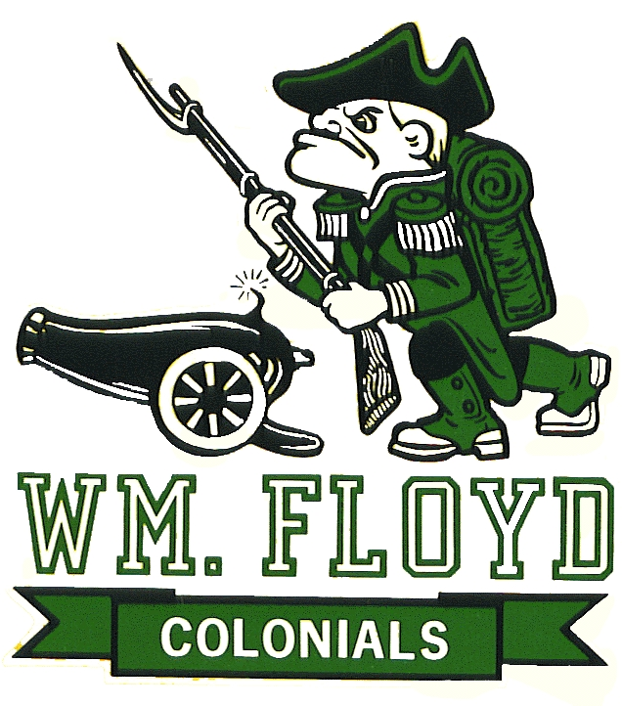

*P.O. Box 536*

*Moriches, NY 11955 – 0536*

www.FloydAlumni.org The Pride Continues…

Dear Business Owner / Organization Leader / Alumni / Friend,

The William Floyd Alumni Association is honoring four Teachers, Administrators, or Mentors who were the driving force by which we, as former students, received our education and developed into the people we are today. These honorees changed our lives, molded us and taught us the principles of life. They were dedicated to our well-being. Now it is time to give them the recognition they so richly deserve.

This year’s Honorees include:

|  |  |
| --- | --- |
| **Mr. Richard Daly** | **Ms. Ruth Trimble** |
| **Dr. Keith Fasciana** | **Mr. Frank Turso** |

On Wednesday, October 18, 2017, we will be holding our 8th Annual Outstanding Educators Award Dinner at the Rock Hill Country Club in Manorville, NY 11949 at 6:30pm. The cost for the event is $55.00 per person or $100.00 per couple. Tickets for children ages 4-12 are $25.00, children under 4 years may attend for free.

We are looking for sponsors and we are also selling journal ads. If you or someone you know would like to sponsor a portion of this event or buy a journal ad it would help ensure for the success of this joyous event. The proceeds from this event will go to fund many of our Alumni initiatives such as: College Scholarships, Support for the WFHS - Career and Technical Education (CTE) Program, Support for the Middle Schools - Science, Technology, Engineering and Mathematics (STEM) Initiatives, Welcome Kindergarten Students with Gift Packets, Holiday Adopt-A-Family, and many more. Please help support these initiatives with your contribution and attendance. The details are as follows:

**Journal Ads:** (Please fill out the enclosed form and mail it back before September 20th with your payment.) Mail checks payable to **William Floyd Alumni Association, Inc.** and mail to **P.O. Box 536, Moriches, NY 11955**. For more information visit our website at www.FloydAlumni.org

1/4 Page Ad - $35.00 1/2 Page Ad - $65.00 Full Page Ad - $125.00

Thank you for your continued support. We hope you can attend this event.

Sincerely,

The William Floyd Alumni Association’s Outstanding Educators Committee

The Pride Continues…

*Some or all of your contributions may be tax deductible, check with your tax advisor.*

**Please make checks payable to:**

# William Floyd Alumni Association, Inc.

## P.O. Box 536

## Moriches, NY 11955

**JOURNAL AD DONATION**

|  |  |
| --- | --- |
| **1/4 Page** | **$35.00** |
| **1/2 Page** | **$65.00** |
| **Full Page** | **$125.00** |
| **Back Page, Cover, etc.** | **Call – (631) 874-1567** |
|  |  |
|  |  |
|  |  |
|  |  |

#### Amount Enclosed_________________

Copy here:

8th Annual





Outstanding Educators

Award Dinner

**Sponsored by the**

**William Floyd Alumni Association, Inc.**

***~ 2017 Recipients Are ~***

|  |  |
| --- | --- |
| Mr. Richard Daly | **Ms. Ruth Trimble** |
| **Dr. Keith Fasciana** | **Mr. Frank Turso** |

***Join us in recognizing these Educators who helped guide us through life’s path.***

# Wednesday, October 18, 2017

**6:30 pm**

#### **Rock Hill Golf & Country Club**

**105 Clancy Road**

**Manorville, NY 11949**

## **Donation: $55.00 per person or $100.00 per couple**

**Tickets for children ages 4-12 are $25.00,**

**children under 4 years may attend for free**.

**Buffet Dinner & Cash Bar**

For more information visit our website at [www.FloydAlumni.org](http://www.FloydAlumni.org)

***Some or all of your contributions may be tax deductible, check with your tax advisor.***